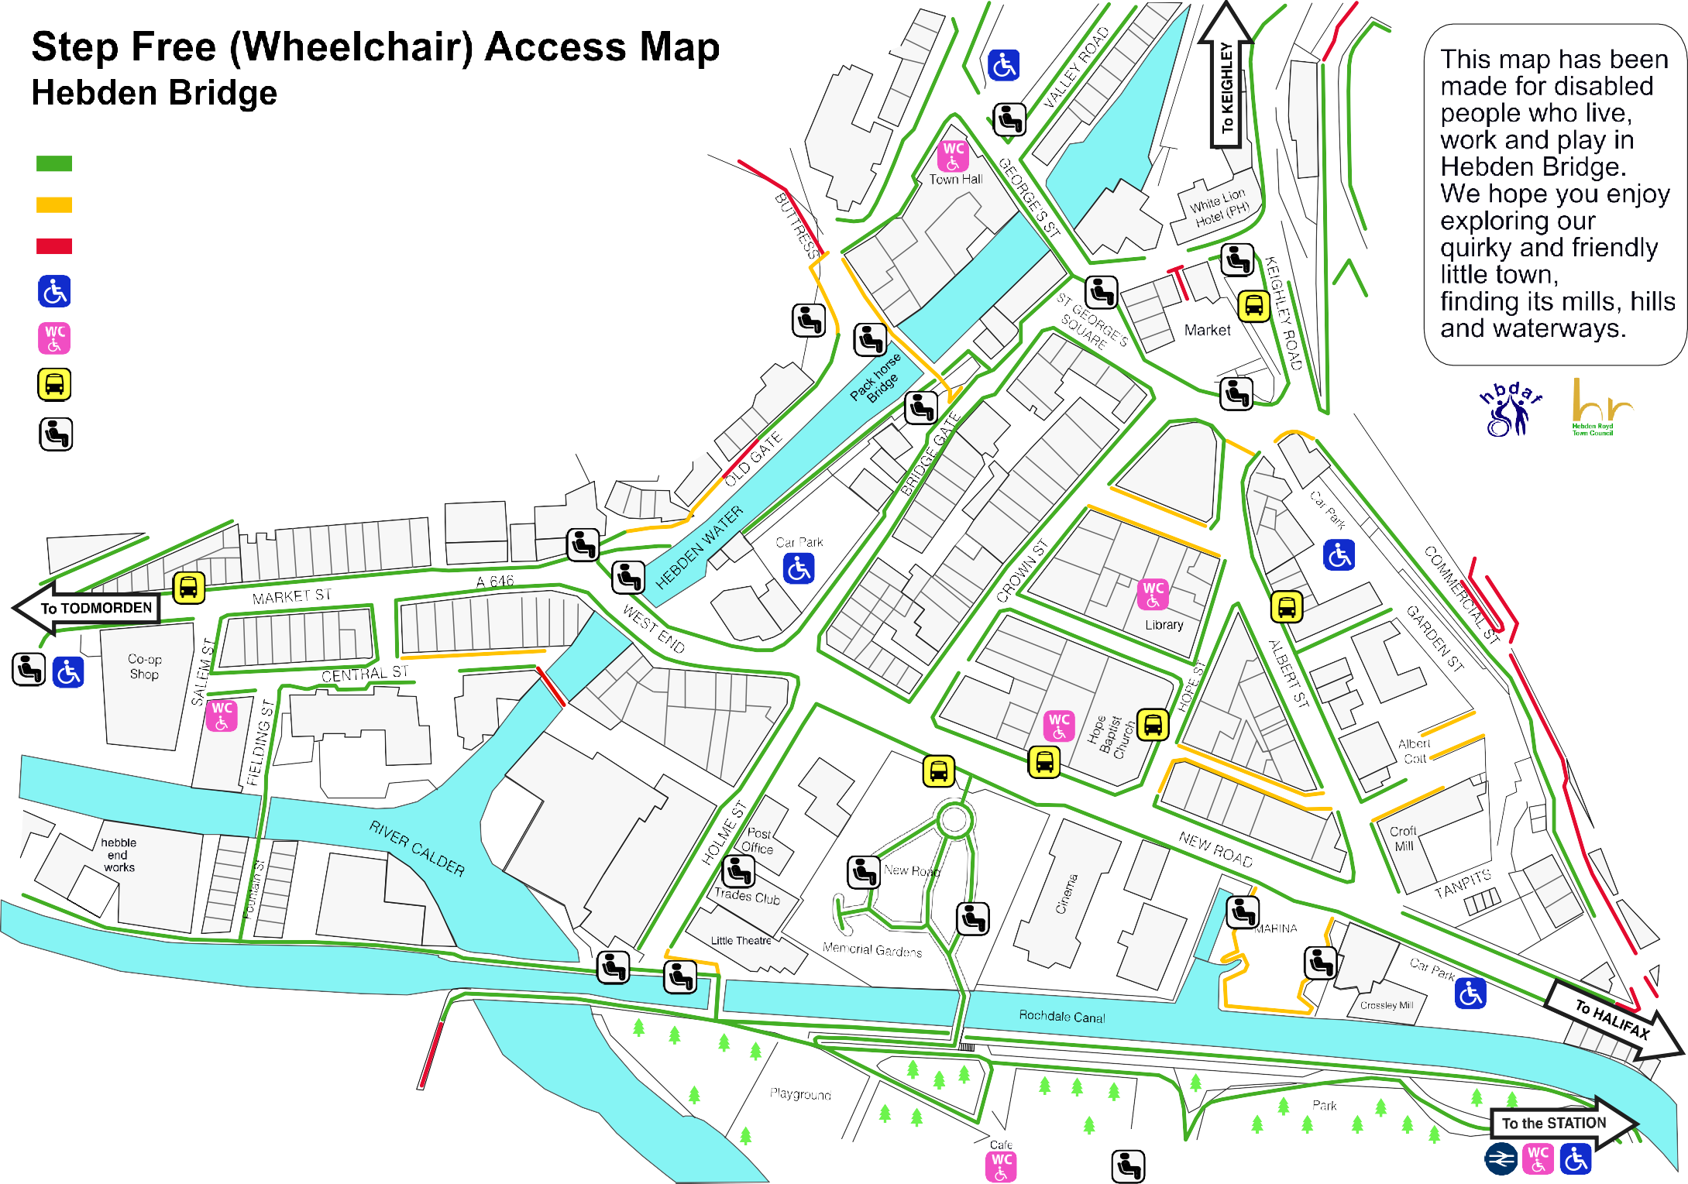

Passable

Passable with caution Not Passable

Blue Badge Parking

Public Accessible Toilets (Radar key) Bus Stop (Accessible)

Public Seating

May 2025

© Copyright Hebden Bridge Disability Access Forum [sechbdisabilityaccess@gmail.com](mailto:sechbdisabilityaccess@gmail.com) - Design by aleon.co

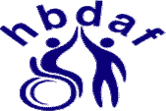**Hebden Bridge Step Free Access Guide to Shops, Cafes and All**

Made by disabled people for disabled people

|  |  |  |  |  |  |  |  |  |
| --- | --- | --- | --- | --- | --- | --- | --- | --- |
| **Albert Street** | | **Bridge Gate** | | **St George's Square** | | | **Market Street** | |
| Sports & Social Club | | Valli Opticians | | The Country Stores | | | Spirals (downstairs) | |
| The Albert Pub | | Reeds Rains | | Dragonfly Boutique | **PR** | | Drink? | |
| Classic Carpets | **PR** | Lotus Nails | | Square One Café | | | The Retreat restaurant | |
| Leila's Kitchen (Outdoor Only) | | The Old North Bar/Café | | Marshall's Bakery | | | Element Jewellery | **HL PR** |
| Coin Bar/Restaurant | **AT** | Dia Del Taco bar/Café | | Rohan Outdoor | **PR** | | JK's Chinese Takeaway | |
| Goo Cheese & cafe | **PR** | Rendezvous Café | **PR** | Mijo | **PR** | | Co-op Supermarket | **DP** |
| **New Road** | | Fat Face | | The Barn (Lees Yard) | | | Methodist Church Hall | **HL AT** |
| Gina B Glass | **PR** | RSPCA Charity | | **Valley Road** | | | Remain in Light | |
| Rim Nam Thai Restaurant | **AT** | Frank & Jasper Menswear | | Town Hall/Café | **HL AT** | | Valley Organics | |
| Flying Saucers Pottery Café | | White Swan Pub | | Forget Me Not Charity | **RA PR** | | Tall Poppies | |
| Calder Community Kindness | | Noir |  | Hebden Therapy Centre | **AT** | | Afghan Rug shop | **PR** |
| HB Picture House **HL RA** | **AT** | Fratelli Artisan Pizza | Mother Bakery | **RA** | | Heart Gallery | **PR** |
| Nightjar bar | | Shoulder of Mutton Pub | **AT** | Marco's Café |  |  | Origano Restaurant | |
| Hope Baptist Church | **AT** | Innovation Shop/Café | | The A World Charity |  | **Crown Street** | |
| Sam's Pizzas | | White Lion Hotel | **AT** | Overgate Furniture | | | The Remedy Bar | **AT** |
| Hair and There | |  | | Valley Medical Centre | **DP AT** | | Fleur de Lys Florist | |
| The Willow Garden Florist | | **Hope Street** | | Hebden Bridge Pharmacy | | | Tipi Store Homeware | |
| HB Little Theatre | **AT** | Library | **AT** | Northlight Art Space/Studios | | | Squeeze Café | **AT** |
| **Old Gate** | |  | | **Holme Street** | | | Weighsted | **PR** |
| Old Gate Bar/Restaurant | **AT** | **West End** | | Trades Club ( Lift ) | **AT** | | Stephen Maskill Butcher | |
| Hope Gallery | **PR** | Dog Friendly Coffee House | | **Calder Holmes Park** | | | The Excited Goat Café | |
| Alma's Cakes & Bakes | |  | | Park Life Café | | |  | |

**AT** = Accessible Toilet **PR** = Portable Ramp available **HL** = Hearing Loop **RA** = Rear Access **DP** = Blue Badge parking All listed are step free, rise less than 2.5cm/1inch for safe use by most wheelchairs. Ramps at own risk.

Accessible toilets - customer use only except Town Hall. Public toilets on map - open times vary, New Road toilet is **always** open.

Park toilet open April - October. Correct to the best of our knowledge

Issued May 2025. ©HBDAF supported by Hebden Royd Town Council [sechbdisabilityaccess@gmail.com](mailto:sechbdisabilityaccess@gmail.com)