22th October 2022

Task & Finish – Cost of Living Crisis

You are hereby invited to a meeting of the **COST OF LIVING CRISIS – TASK & FINISH GROUP** (Cllrs: Boggis, Guilfoyle, Fraser, Needham & Stevens) which will be held in the **GREENWOOD Room** in Hebden Bridge Town Hall on **TUESDAY 25th October 2022** at **10.30am**

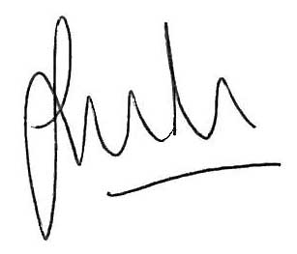

Jason Boom

Clerk to the Council

**INITIAL MEETING – TASK & FINISH AGENDA**

1. **APOLOGIES & SUBSTITUTES**
2. **TASK & FINISH GROUP STRUCTURE**
3. **DELEGATED POWERS & BUDGET**

To confirm arrangements.

1. **HRTC REPRESENTATIVES ON OTHER BODIES**
2. Local Action Groups – Luddendenfoot & Calder Wards
3. Anti – Poverty Steering Group
4. Food Poverty Network
5. **POSSIBLE AREAS OF HRTC SUPPORT**
6. Food/voucher support principles – additionally to consider funding requests as part of this discussion deciding on a date to meet the applicants once the principles have been decided.
7. ‘Warm spaces’
8. Community Meals
9. HRTC Staff
10. Other suggestions
11. Administration of support