27 May 2025

Under the Openness of Local Government Bodies Regulations 2014, members of the public, the press or the Council may record/film/photograph or broadcast the meeting whilst it is open to the public.

**To Members of the Council**

Dear Sir/Madam

You are hereby summoned to a meeting of the **PICTURE HOUSE COMMITTEE** (Cllrs: Courtney, Guilfoyle, Hodgins, Needham, Stow & Wood) which will be held in the Council Chamber on **MONDAY 13th June 2022** at **7.30pm**

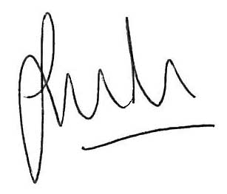

Jason Boom

Clerk to the Council

This meeting is open to the public unless Members decide to exclude   
the public for any exempt or confidential item of business.

# **ELECTION OF CHAIR AND DEPUTY CHAIR OF THE PICTURE HOUSE COMMITTEE 2022/23 (role of a committee chair enc).**

1. **To receive apologies for absence and any substitutions.**
2. **To receive members` interests relating to agenda items for this meeting.**
3. **To report on matters arising from the minutes of Advisory meeting held 7th March 2022 not itemised on this agenda.**
4. **FRIENDS OF THE PICTURE HOUSE**

To receive update on activities of the Friends of the Picture House.

1. **MANAGERS REPORT**

To receive Managers Report inc: cumulative analysis, kiosk improvements, programming (the film slate) & programming initiatives and ticketing review. To decide on actions as appropriate (enc).

1. **FINANCIAL REPORT**

To receive final accounts for 21-22 and the agreed budget for 2022.

To discuss the Picture House Forecast til end April 2022 and the use of HRTC Financial Support for 2022/23 and to decide on actions as appropriate (enc).

1. **MARKETING REPORT**

To receive report from the Marketing Officer (enc).

**9. PROJECTOR**

To verbally report on the procurement and install of the projector and to consider any further actions required.