07 July 2016

To Members of the Council

Dear Sir/Madam

A meeting of the Twinning Committee (Cllrs; Davenport, Fekri, Timbers & Trickett) will be held in the Council Chamber, The Town Hall, St George’s Street, Hebden Bridge on WEDNESDAY 23rd OCTOBER 2013 at 6:30 pmk
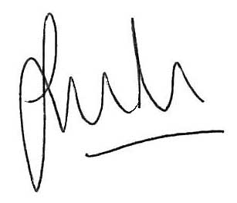

Jason Boom

Clerk to the Council

This meeting is open to the public unless Members decide to exclude
the public for any exempt or confidential item of business.

AGENDA

Apologies for Absence and any substitutions

Members` Interests relating to agenda items for this meeting.

BUDGET 2014/15
To consider and make recommendations on budget requirements for 2014/15.

- COUNCIL YEAR 2013/14
To receive advice on Councillors attendance at Twinning Events as discussed at the last meeting and to seek further confirmations of attendance.

- TOUR DE FRANCE
To receive an update on progress and to make decisions as appropriate.

- CELEBRATION OF THE LIBERATION OF ST POL
To receive report on progress.

- TWINNING ANNIVERSARIES 2014
To confirm arrangements for the 35th Anniversary with St Pol to be held in St Pol.

DATE OF NEXT MEETING
Wednesday 29th January 2014 at 6.30pm.

