01 December 2017

To Members of the Council

Dear Sir/Madam

A meeting of the Community Funding Committee (Cllrs; Bampton Smith, Cammack, Courtney, Fearon, Fenton & Stow) will be held in the Greenwood Room, The Town Hall, St George’s Street, Hebden Bridge on MONDAY 11th DECEMBER 2017 at 6:30 pm.
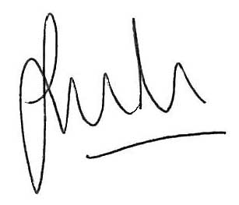

Jason Boom

Clerk to the Council

This meeting is open to the public unless Members decide to exclude
the public for any exempt or confidential item of business.

AGENDA

Apologies for Absence and any substitutions.

Members` Interests relating to agenda items for this meeting.

Matters arising from Minutes of Meeting held 11th September 2017 not itemised on this Agenda.

4. BUDGET UPDATE 2017/18 & BUDGET REQUEST 2018/19
To receive report detailing current expenditure, as part of Clerks comments, and to consider the budget request for 2018/19.

5. COMPLETED PROJECT EVALUATIONS
To receive evaluations of supported projects and to decide on actions as appropriate.
(Evaluations are available prior to the meeting in the Town Clerks Office).

6. COMMUNITY FUNDING PRIORITIES
To consider, discuss and approve revised Funding Priorities (enc).

7. COMMUNICATIONS
a) Friends of Hebden Bridge Train Station.
b) Trainees at the Handmade Parade
c) Completion of Payments – Mytholmroyd Station Partnership
d) Heptonstall Village Team
e) Mytholmroyd Gala – Verbal Update.

8. CLERKS COMMENTS
To receive and consider comments made by the Town Clerk relating to applications for financial support from the Council (enc).

9. REQUESTS FOR FINANCIAL ASSISTANCE FROM THE COUNCIL
a) Hebden Bridge Folk Roots Festival 7.00pm
2018 Festival £4,928.00

b) Pennine Prospects 7.20pm
FLY! The South Pennine Kite Festival 2018 £5,000.00

c) Calder Valley Community Land Trust Ltd 7.40pm
Hebden Bridge High Street £4,5000.00

d) Awakening Arts 8.00pm
Dementia Care Group £3,000.00
(awaiting additional documentation which will be available at the meeting)

